

|  |  |
| --- | --- |
| DATE | 10 OCTOBER 2022 |
| TEAM ID | PNT2022TMID12733 |
| PROJECT NAME | IOT BASED SAFETY GADGET FOR CHILD SAFETY MONITORING AND NOTIFICATION |
| TEAM LEADER | ADARSH KARAN K P |
| TEAM MEMBERS | ROSHITH BABU  NARAYANAN A  THENNARASU A |

|  |  |  |  |  |  |  |
| --- | --- | --- | --- | --- | --- | --- |
| **User Type** | **Functional**  **Requirement (Epic)** | **User Story**  **Number** | **User Story / Task** | **Acceptance criteria** | **Priority** | **Release** |
| **Customer**  **(Mobile user)** | Registration | USN-1 | As a user, I can register for the application by  entering my email, password, and confirming my password. | I can access my account /  dashboard | High | **Sprint-1** |
|  |  | USN-2 | As a user, I will receive confirmation emailonce I have registered for the application | I can receive confirmation email & click confirm | High | **Sprint-1** |
|  |  | USN-3 | As a user, I can register for the application through Facebook | I can register & access the dashboard with IBM Login | Low | **Sprint-2** |
|  |  | USN-4 | As a user, I can register for the application  through Gmail |  | Medium | **Sprint-1** |
|  | Login | USN-5 | As a user, I can log into the application by entering email & password |  | High | **Sprint-1** |
|  | Dashboard |  |  |  |  |  |
| **Customer Care Executive** | login |  | As I enter I can view the working of the application and scan for any glitches and monitor the operation and check it all the users authorized. | I can login only with my provided credentials. | Medium | **Sprint-3** |
| **Administrator** | login |  | Maintaining and making sure the database containing the locations are secure and accurate and update constantly. | I can login only with my provided  credentials. | High | **Sprint-4** |
| **Customer (web user)** | login |  | As a user, I can register for the application byentering my email, password, and confirmingmy password. | I can access my account / dashboard | High | **Sprint-2** |
|  |  |  |  |  |  |  |
|  |  |  |  |  |  |  |
|  |  |  |  |  |  |  |
|  |  |  |  |  |  |  |

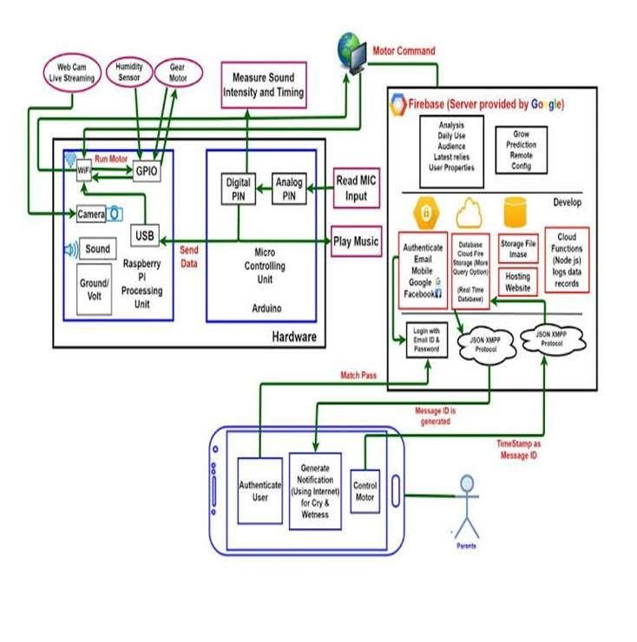Data Flow Diagram